Predicting Audiences Scores from Movies Attributes:
A Comparative Analysis of Critics and Audiences Ratings
Introduction
The divergence between critics' reviews and audience ratings has long been a topic of interest in the film industry. This difference is essential for stakeholders such as production companies, marketers, and streaming platforms. This project aims to identify the factors influencing audience ratings and predict these scores using machine learning models. The data for this study was sourced from Kaggle and included detailed movie information and reviews.
This analysis has practical significance. By identifying drivers of audience ratings, production companies can tailor marketing strategies or production decisions to better align with audience preferences. Additionally, streaming platforms can use these insights for content recommendation systems. This problem can be pitched to stakeholders to enhance viewer satisfaction and optimize production investments.
Milestone 1: Data Selection and Exploratory Data Analysis (EDA)
Objective: This milestone focused on identifying a business problem, selecting appropriate data, and performing initial exploratory data analysis to uncover insights.
Activities:
- Problem Identification: The project centers on understanding why audience ratings often differ from critic ratings and predicting audience scores using movie attributes.
- Data Source: The dataset was from Kaggle, containing information such as movie titles, genres, runtime, critic reviews, audience reviews, and numerical ratings from both groups.
EDA Highlights:
- Histogram of Critic and Audience Ratings:
- Revealed that audience ratings were generally higher and clustered more narrowly than critic ratings, which showed a wider distribution.
- Implication: Critics and audiences may prioritize different aspects of movies.
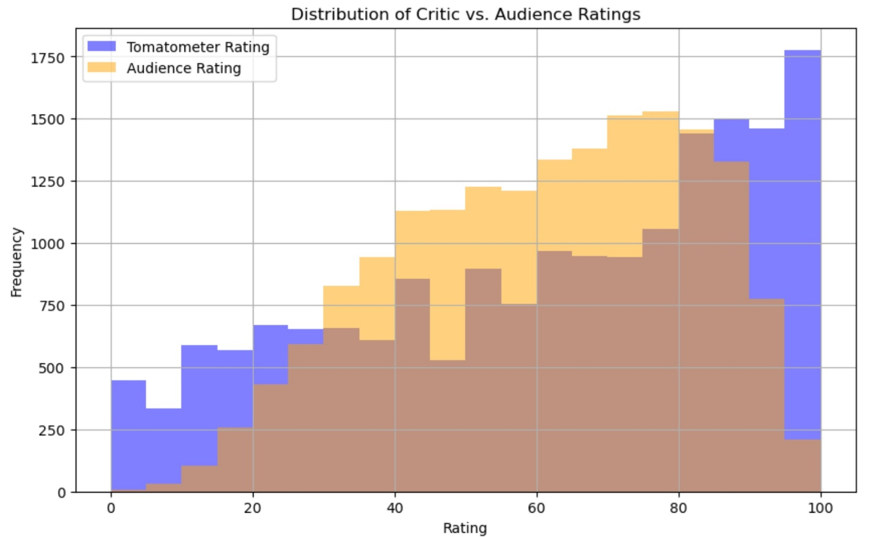Figure 1. Distribution of Critic and Audience Ratings
- Box Plot of Ratings:
- It showed a more significant variance in audience ratings, indicating diverse preferences.
- Implication: Audience scores are likely influenced by multiple external factors, such as genre and sentiment.
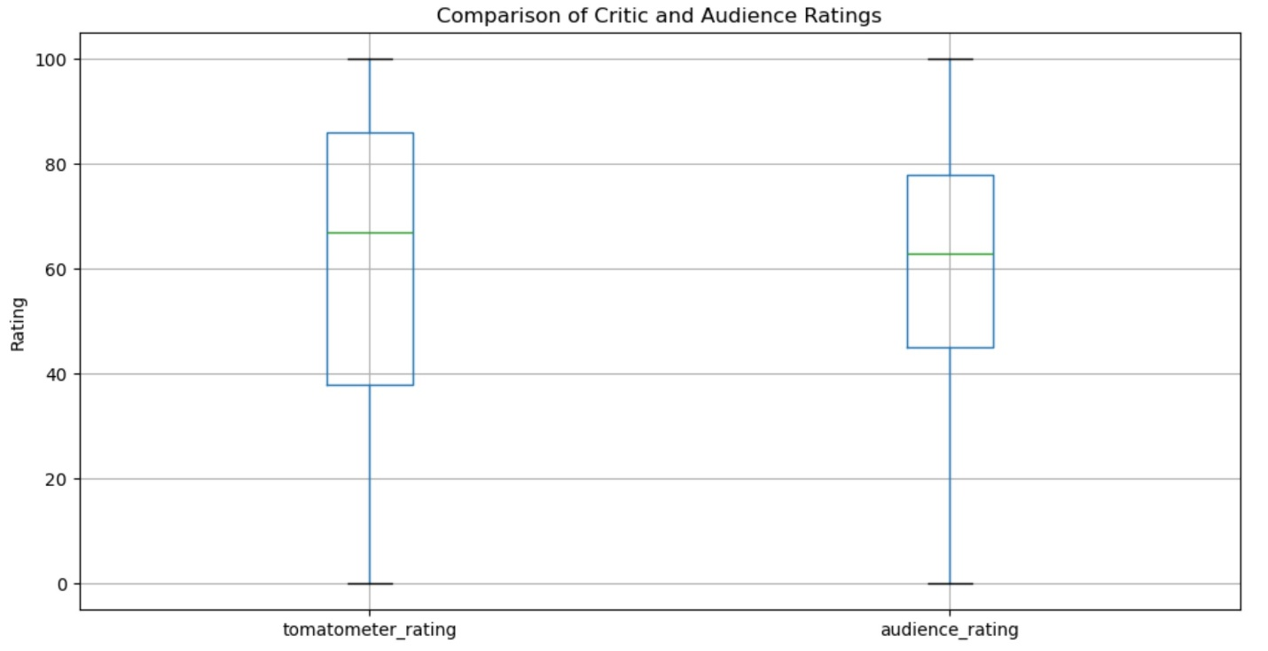Figure 2. Box Plot of Critic and Audience Ratings
- Scatter Plot of Ratings Correlation:
- A moderate positive correlation was suggested, but with many outliers, emphasizing the divergence in perspectives.
- Implication: Predictive modeling must capture unique audience preferences.
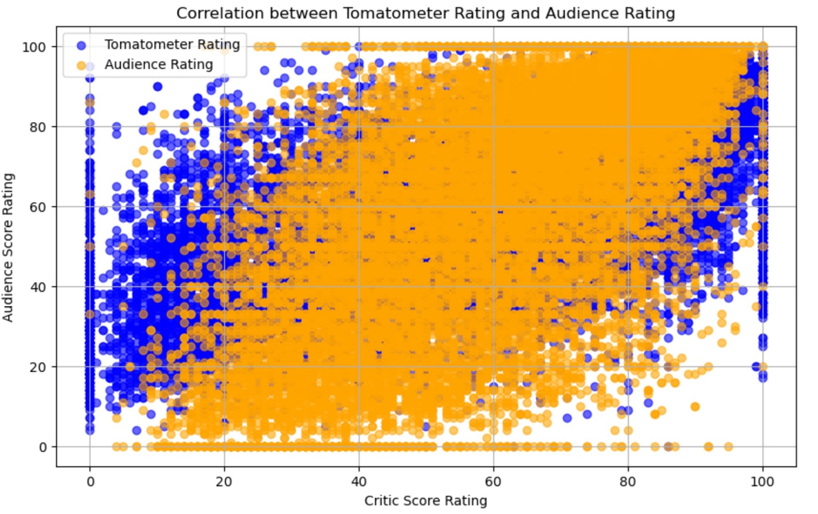Figure 3. Scatter Plot of Correlation Between Critic and Audience Ratings
Milestone 2: Data Preparation and Feature Engineering
Objective: Prepare the data for modeling by cleaning, transforming, and engineering new features.
Activities:
- Data Cleaning:
  - Removed unnecessary columns (e.g., links and redundant identifiers).
  - Handled missing values by imputing or dropping rows/columns as appropriate.
- Feature Engineering:
  - Created dummy variables for categorical data (e.g., genres, directors).
  - Extracted sentiment scores from text reviews to capture audience emotions.
  - Added derived metrics, such as review count and critic-audience rating differences.
- Data Transformation:
  - Normalized numerical features (e.g., runtime) for consistent scaling.
  - Ensured all variables were in a model-compatible format.
Outcome: The dataset was transformed into a clean and structured format, with all features ready for machine learning models.
Milestone 3: Model Building and Evaluation
Objective: Develop and evaluate models to predict audience ratings based on the prepared data.
Activities:
- Model Selection:
- Started with Linear Regression to establish a baseline for performance.
- Used Random Forest and Gradient Boosting Machines to capture non-linear relationships.
- Model Evaluation:
- Evaluated models using metrics such as Mean Absolute Error (MAE) and Root Mean Squared Error (RMSE).
- Ensemble models (Random Forest and Gradient Boosting) significantly outperformed Linear Regression, indicating that complex patterns influence audience ratings.
- Feature Importance:
- Analyzed which features contributed the most to predictions, with sentiment scores, genres, and runtime being top predictors.
Outcome: A predictive model was developed and fine-tuned, showing strong performance in capturing audience preferences.
Conclusion
The analysis revealed several significant findings:
- Sentiment from reviews plays a significant role in predicting audience ratings, underscoring the importance of emotional factors.
- Ensemble models outperform simpler models, suggesting that the relationship between predictors and audience ratings is complex and non-linear.
Recommendations:
- Further fine-tuning of models, such as hyperparameter optimization, could improve performance.
- Incorporating additional data sources, like social media sentiment, may enhance predictive capabilities.
- The model can be deployed for platform pilot testing to gauge its practical effectiveness.
Challenges and Opportunities:
- Sentiment analysis was limited to review text. Expanding this to include visual data, such as trailers, could enrich the analysis.
- Biases in the dataset, such as overrepresenting certain genres, need to be addressed in future iterations.

References
Data Source:
- Kaggle. (n.d.). Rotten Tomatoes movies and critic reviews dataset. Retrieved from https://www.kaggle.com/datasets/stefanoleone992/rotten-tomatoes-movies-and-critic-reviews-dataset

